### **31. IPv6: Part 1**

#### **Hexadecimal (Review)**

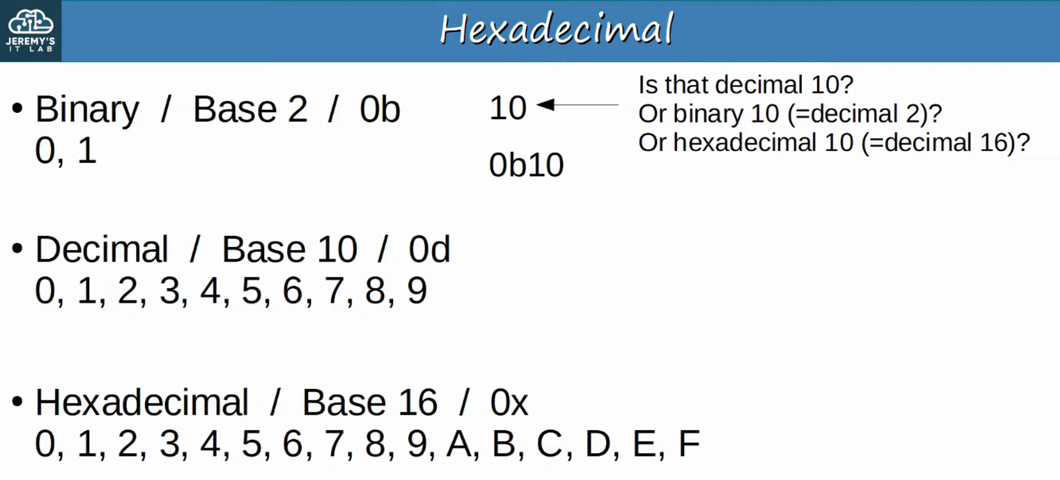 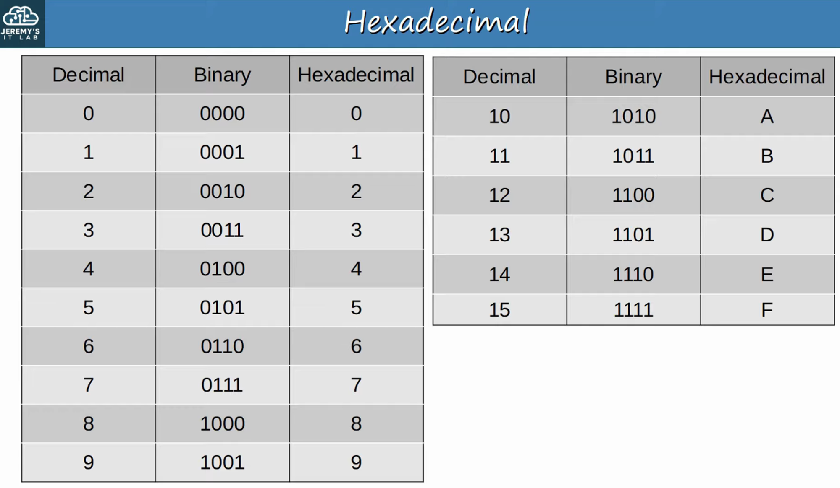  
 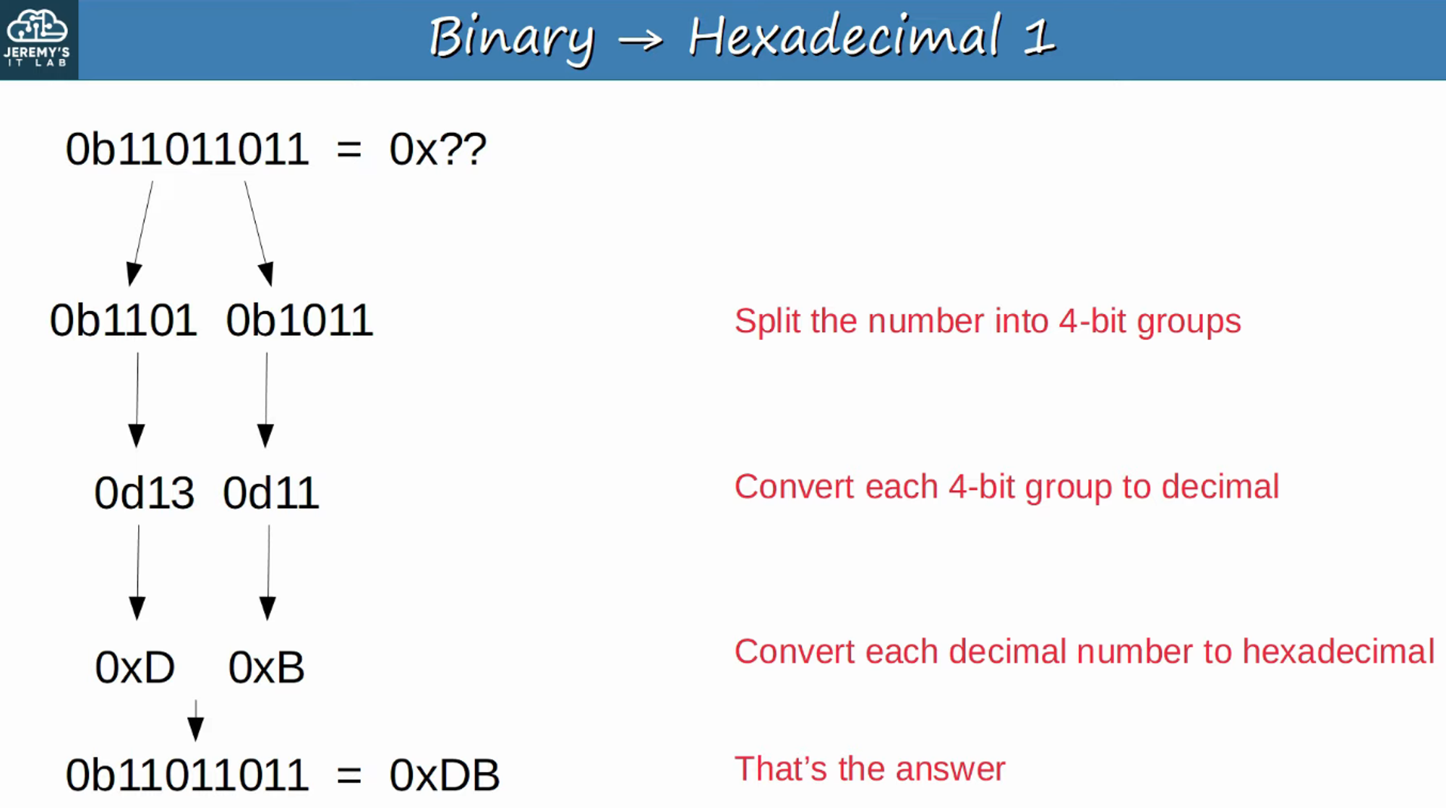

**What about the reverse (Hex to Binary)?** 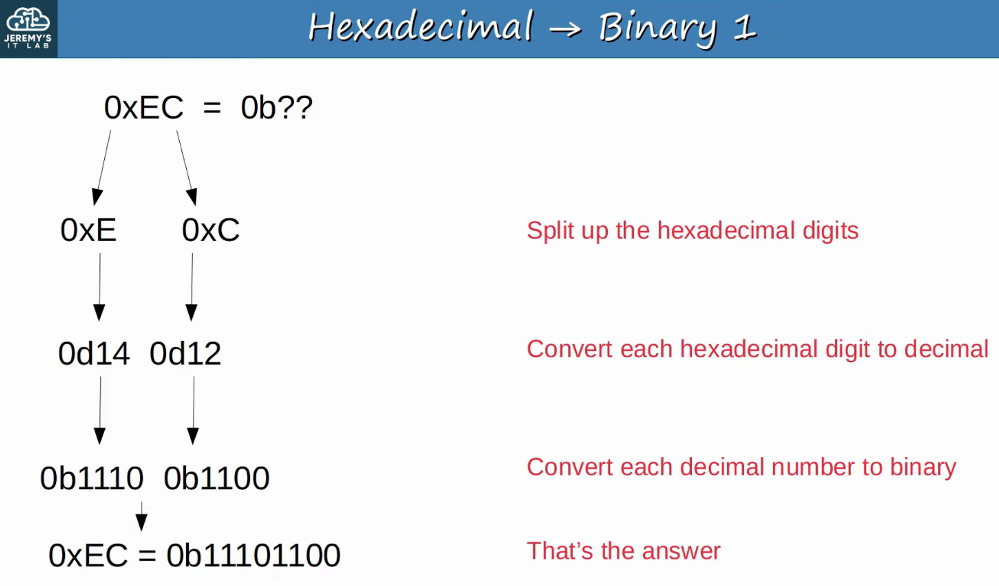

### **Why IPv6?**

* The **main reason**: There are not enough IPv4 addresses available.
* There are **2³² IPv4 addresses** (4,294,967,296 total).
* IPv4 was designed over 30 years ago, with no foresight into today’s Internet scale.
* **Short-term solutions** to conserve IPv4 space include:
  + **VLSM (Variable Length Subnet Masking)**
  + **Private IPv4 addresses**
  + **NAT (Network Address Translation)**
* However, the **long-term solution** is **IPv6**.

**IPv4 Address Assignments:**

* Controlled by **IANA (Internet Assigned Number Authority)**.
* IANA distributes IPv4 space to **RIRs (Regional Internet Registries)**, who allocate them to organizations.

Key Milestones:

* **September 24, 2015**: ARIN declared exhaustion of IPv4 address pools.
* **August 21, 2020**: LACNIC made its final IPv4 allocation.

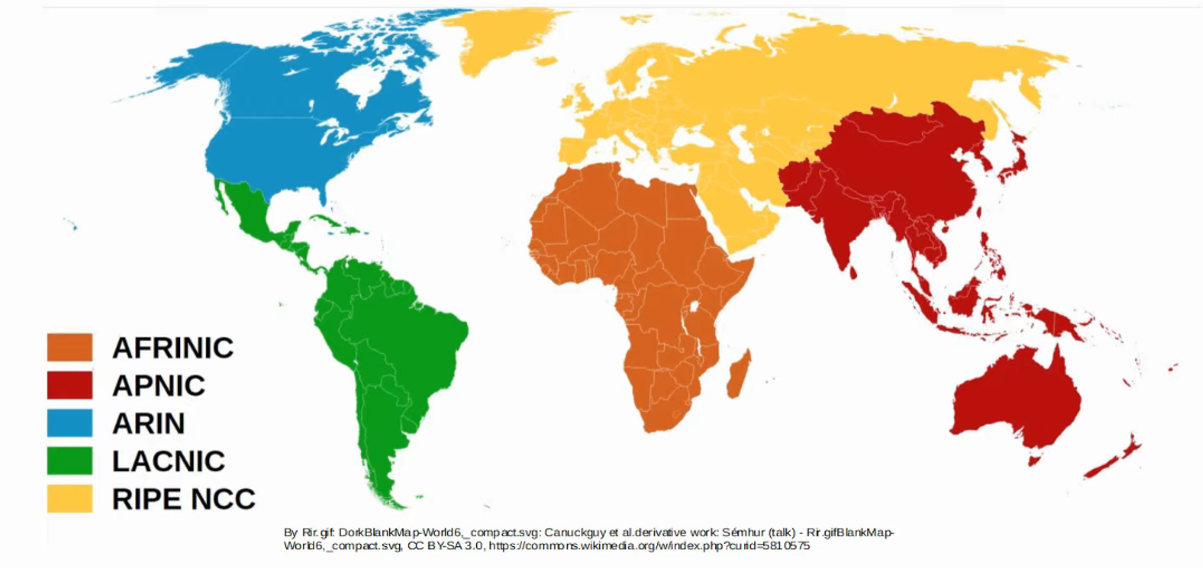

### **Basics of IPv6**

* IPv6 addresses are **128 bits (16 bytes)**.  
   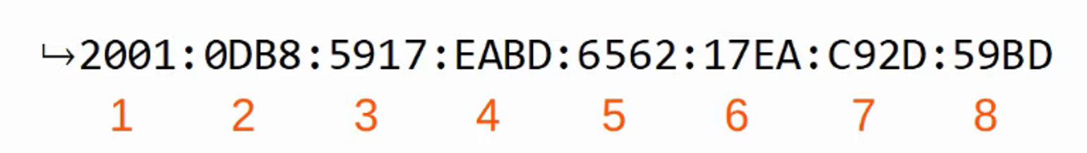
* IPv6 uses a **/prefix number** for subnetting.

### **Shortening IPv6 Addresses**

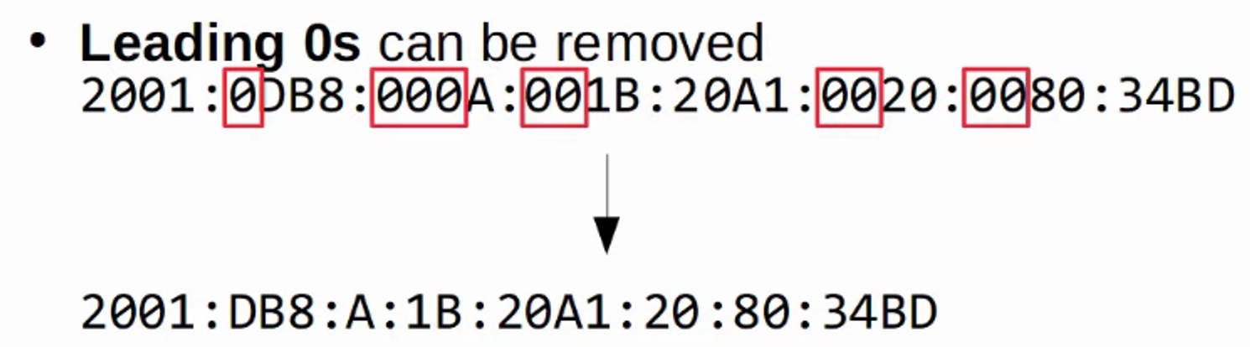 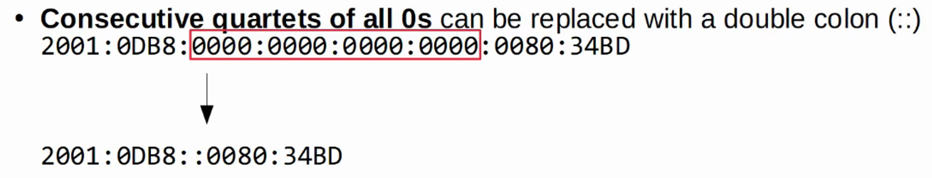

**Key Rule**: You can **only remove leading zeros**.  
 Example:  
 2001:0DB8:8B00:0001:FB89:017B:0020:0011 becomes 2001:DB8:8B00:1:FB89:17B:20:11.

### **Expanding IPv6 Addresses**

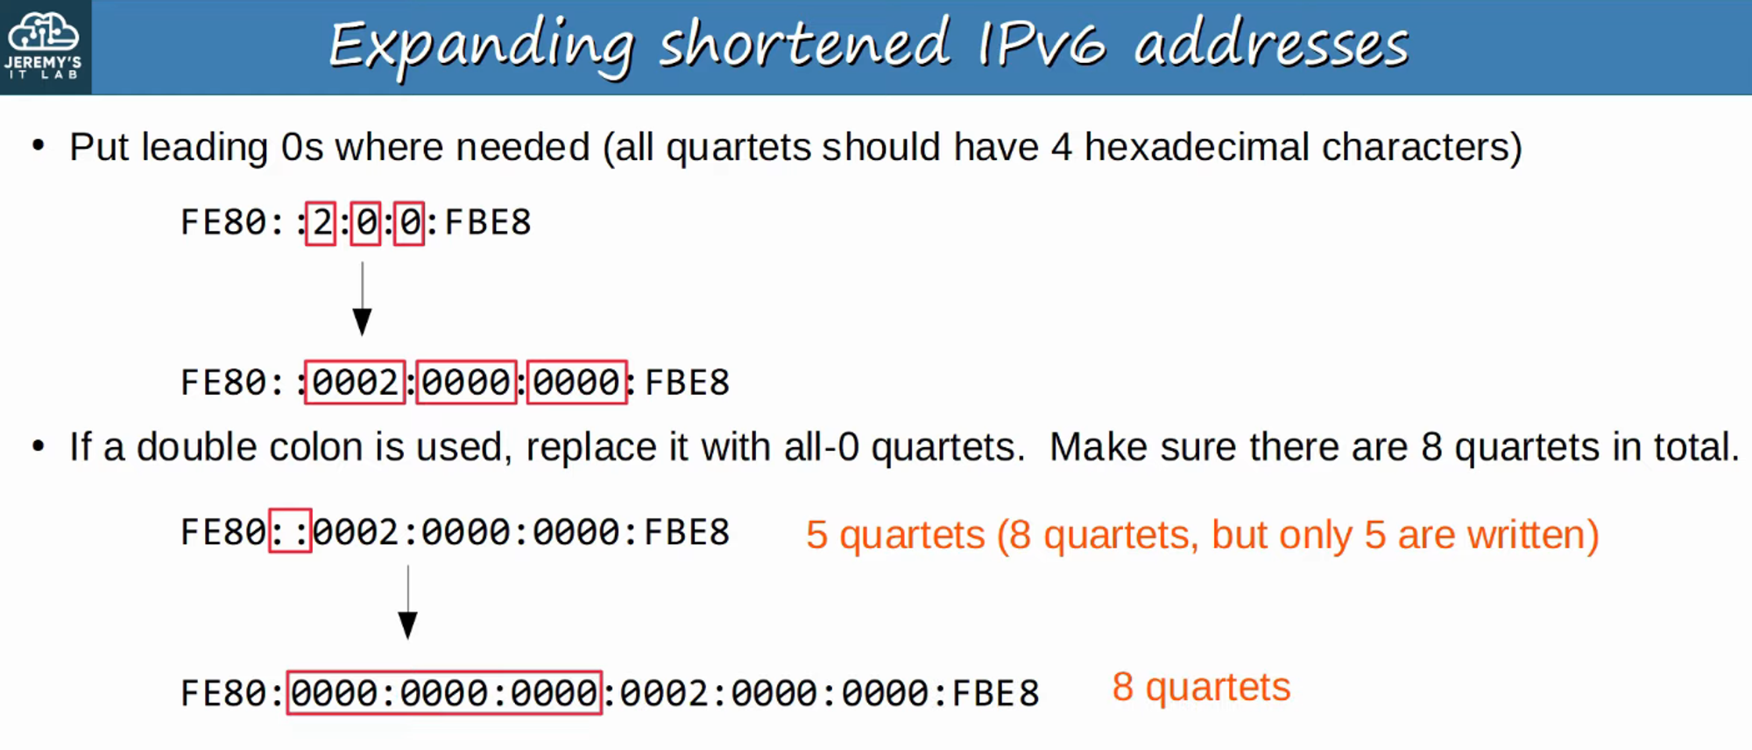

### **Finding the IPv6 Prefix (Global Unicast Addresses)**

* Enterprises typically receive a **/48 block** from their ISP.
* IPv6 subnets generally use a **/64 prefix length**.
* This gives enterprises **16 bits for subnetting** and **64 bits for hosts**.

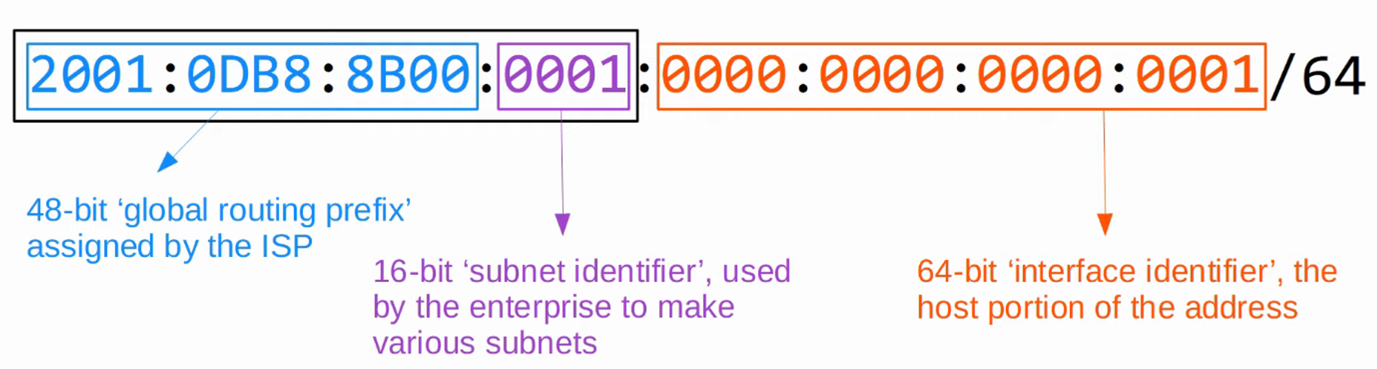

**Reminder**: Each digit = 4 bits, each block = 16 bits.

### **Configuring IPv6 Addresses**

Enable IPv6 routing on a router:

R1(config)# ipv6 unicast-routing

Assign an IPv6 address to an interface:

R1(config)# int g0/0

R1(config-if)# ipv6 address 2001:db8:0:0::1/64

R1(config)# no shutdown

You can also use the full IPv6 address, if necessary.  
 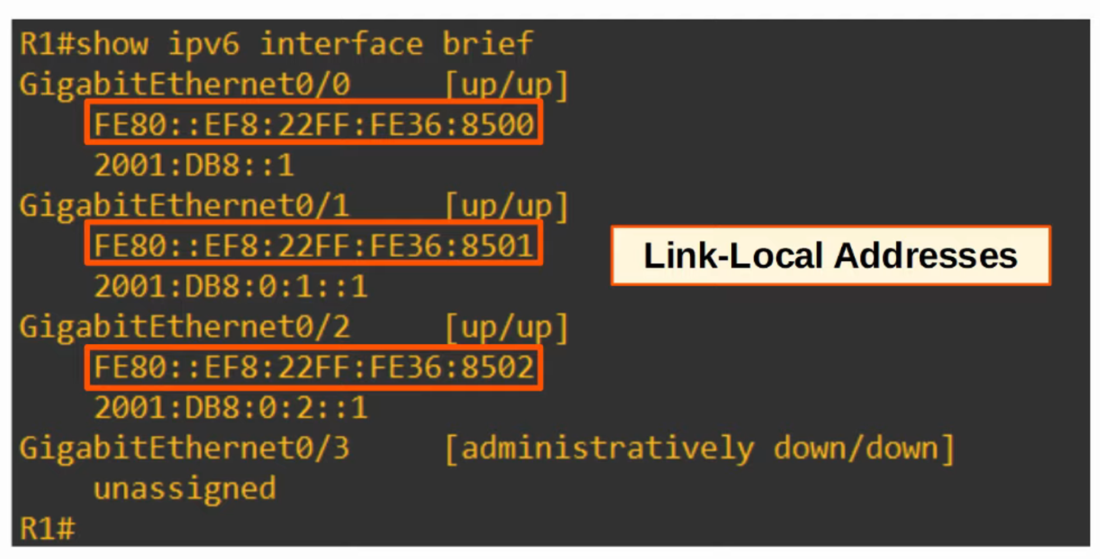

### **Link-Local Addresses**

* Automatically added when creating an IPv6 interface.
* Covered further in **IPv6: Part 2**.